DEVELOPING PUBLIC AWARENESS AND A POSITIVE ATTITUDE TOWARDS LOCAL AIRPORTS / AIRFIELDS

Attachment D

INTERACTIVE WORKSHOP FOR COMMUNITY LEADERS

The purpose of this approach is to establish a working dialogue between the airport interests and town leaders by addressing the role of the airport as a link in their economic development effort.

Many of the smaller towns have found that creating an industrial or commercial area near the airport has been a considerable factor in attracting new business to their area.

A more in-depth workshop outline is also shown. It does require an experienced facilitator with a general knowledge of aviation and airports. The goal is the same as the shorter type of workshop.

THE AIRPORT LINK IN ECONOMIC DEVELOPMENT

This workshop is to explore the relationship of the airport its local community and to further its role in the economic development of the general area.

09:00 Registration and Coffee

10:00 Opening - Edited Version of “Prairie Skies” video and remarks
State Director of Aeronautics.

10:15 Keynote Address - “The General Aviation Airport in Perspective”

10:45 BREAK

11:00 Issue for Discussion
Panel - Who’s Responsible For a Successful Airport?
Building the Airport
Operating the Airport
Using the Airport
Merging Into Community Economics

11:30 Luncheon break with AOPA speaker on the elements of successful small airport
operation (Business Administration, Planning, Marketing, etc.)

14:00 Issue for Discussion (Continued)
Panel - Community Perspectives Of The Airport
Economic Development Opportunities
Community Support (tangible and intangible)
User Considerations

14:45 BREAK

15:00 Working Groups Discussions Topic:

Explore the concept of forming a cooperative effort to create a new
level of community-airport relations.



COMMUNITY AIRPORTS INTERACTIVE WORKSHOP

Facilitated by National - Louis University

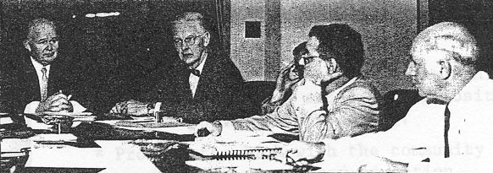

- General Definition of Aviation Activities
Types of Flying and Benefits of Each
Types of Airports and Characteristics of Each

- Airport Place in the Community
Heritage
Purpose:
Transportation
Humanitarian Aspects
Economic Generation
Case Studies

- Government vs. Private Sector Role in Life of the Airport
Construction and Planning
Regulating Agencies
Private Enterprise
Land Use

- Practical Airport Economics
Business Practices - Management Skills
Cost of Regulatory Mandates
Taxation and Fees

- Planning for Economic Development
Zoning Considerations
Intermodal Transportation Considerations
Integration with Community Plans

- Localized Action Plan to Create Success
User / Community Support Group Participation
Master Plan Development

