DEVELOPING PUBLIC AWARENESS AND A POSITIVE ATTITUDE TOWARDS LOCAL AIRPORTS / AIRFIELDS

Attachment E

THE AIRPORT RESOURCE FORUM

The Airport Resource Forum (ARF) provides for the pro-active interaction between the aviation interests on the airport, the town business community, the public and the airport management.
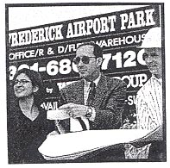
The objective of the ARF is to provide a variety of perspectives and assist in research related to airport development projects. ARF will also assist in informing the public and the aviation interests about airport operations and planned development through periodic public discussion meetings.

Specific goals are:

- Maintain an open forum for discussion concerning the airport through scheduled meetings.

- Provide assistance to the airport staff concerning the Airport Master Plan.

- Research support to assist in planning specific airport issues and drafting position reports for the public understanding.

- Provide the link with the community for information and airport related education.

- Draft an Annual Report to the Town Council outlining airport development issues and achievements.

The members of the Airport Resource Forum to be comprised of the following representatives appointed by the Town Council:

- Member of Airport Business Interest
- Member From Local University
- Member From Pilot Association On Airport
- Member From Chamber of Commerce—Economic Development
- 3 Members From The General Public

The Chairman of the SF will be elected from the membership for a one year term.

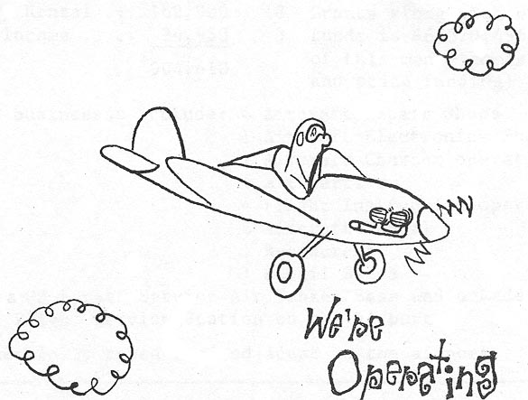
The Airport Manager will be an ad hoc member of the ARF and will provide guidance on the work agenda established and the schedule of meetings.

