DEVELOPING PUBLIC AWARENESS AND A POSITIVE ATTITUDE TOWARDS LOCAL AIRPORTS / AIRFIELDS

Attachment F

CONCEPT OF AN AIRPORT VISIONING CONFERENCE

The status and future of an airport is a frequent topic of discussion. Airports are often operated with a complex mix of users, business and government involvement. Most airports have the potential to become a more valuable asset of their Community.

Strategic visioning defines what we would like the airport to become. This is in contrast to Strategic Planning which is a concise description of how the airport will develop and function relative to prescribed guidelines, combination of the two approaches allows the greatest opportunity for an airport success pattern.

With more freedom to explore without the traditional limits of structured planning, the Visioning Conference offers the best tool to build a consensus regarding the future of an airport.
A Case Study
A case study of such an approach is the “Love Field Beyond 2000” Visioning Conference which was held in 1996 and its success is now a matter of record.

As background, the Prescott Airport is owned and operated by the City of Prescott, Arizona. A brief description of the airport at the time of the Visioning Conference is as follows:
Prescott’s Love Field is a mid-sized general aviation airport which ranks as the second busiest in Arizona and 32nd in the nation.

Approximately 284 aircraft are based at the airport. Embry-Riddle University, along with three other flight schools, operate about 67 training airplanes. Over-all, it is estimated that over half of the based aircraft are used to some degree for business purposes.

The Airport Manager currently has full time staff of 5 with several part time employees.

Oversimplified, the Fiscal Year 1996-97 budget is as follows:

Revenue %
Fuel Sales $424,500 47%
Hanger & Tie-down Rental $253,116 32%
Other Facility Rental $162,900 18%
Miscellaneous Income $ 24,950 3%
Total $904,610

Note: Total Operating Expense is budgeted at $$786,340. The budget for Capital Investment Grants along with other available funds is $6,370,496 (most of this money comes from Federal and State funding).

Airport based businesses include: 4 Aircraft Repair Shops, 1 Aircraft Electronics Shop,1 Aircraft Charter operation, 1 Air Carrier, 4 Flight Instruction operations, 2 Aircraft Rental, 1 Restaurant, 1 Retail Sales.

Also, there is a US Forest Service Air Tanker Base and a Administration Flight Service Station on the airport. There is commercially zoned land adjacent to the airport.

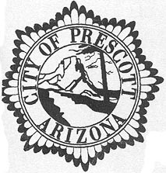

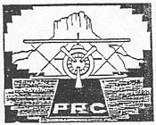
LOVE FIELD BEYOND 2000
An Airport Visioning Conference

THE PLAN OF ACTION

The status and future of the Prescott Airport is a frequent topic of discussion. It is presently a good example of a municipal facility which must operate with a very complex mix of users, businesses and government activity. The airport, however, has a considerable potential to become an even more valuable asset of the Prescott community.

The Airport Master Plan and the Business Plan address the facilities and the operation of the airport but are constrained within the guidelines that have been established.

This leads to the belief that a formal effort should be made to look beyond these specifics. The visioning conference method accommodates this need.

Strategic visioning defines what we would like the airport to become, in contrast to strategic planning, which is a concise description of how the airport will develop and function. The combination allows the greatest opportunity for an airport success pattern.

The proposed Visioning Conference, under the auspices of the Airport Advisory Committee, would invite the broadest representation of airport interests to share ideas and viewpoints as to the future of the Prescott Airport.

The conference would focus on three questions about the airport:

- Where are we now?
- Where do we want to be?
- How can we get there?

The objective output of the conference should include:

- To provide input to the committees working on the airport’s Master Plan and Business Plan.

- Provide useful information to the airport management for plans and policies.

- Assist in the development of a greater sense of “airport community” and cooperative participation in airport affairs.

- Create the foundation for an effective airport-Prescott community relations / or education program.

The conference plan will be implemented through three phases:

- Establishing the airport profile
- The formal conference activity
- Drafting the summary document

The visioning concept is a realistic adjunct to the planning process, especially in today’s atmosphere of rapid changes impacting our society and certainly the Prescott community.

LOVE FIELD BEYOND 2000
An Airport Visioning Conference

The Prescott Airport Visioning Conference was proposed as a solution to solve the considerable turmoil surrounding the airport. The City Council, Airport Users Association, Chamber of Commerce Aviation Committee and the appointed Airport Advisory Committee had a negative view of the airport operation.

There was general agreement that action was needed. Research indicated that the visioning concept had much merit and the following three phase plan of action was agreed upon:
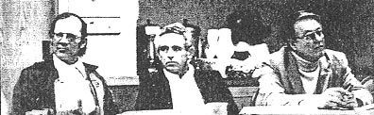

PRESCOTT AIRPORT VISIONING CONFERENCE PLAN
GENERAL OUTLINE

Phase I A small invitation group will define the underlying airport issues and
viewpoints as exist today. Also profile the status of the airport and
the relationship with the Prescott community.

Phase II Structure Of The Formal Conference:

- Keynote Speakers
- Address national trends / issues
- Airport success factors and challenging realities

- Panel Discussion
- Where are we now?
PRC Mission Statement
Master & Business Plans
Airport profile
Economic impact
Community relations
Finance factors

- Expanded Discussion
- What would we like the airport to become?

- Expanded Panel Discussion
- How can our desires be realistically achieved?

Phase III Drafting the conference report for review and publication.
Evaluating the report and determining feasible follow-through actions.

LOVE FIELD BEYOND 2000
An Airport Visioning Conference

Phase I Action

This meeting was held with 12 participants representing City/Airport management, airport users, business interests, near airport homeowners, civic leaders and the Federal Aviation Administration.

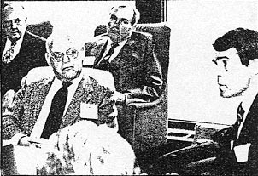
A pre-meeting survey had each participant list the 3 best things about the airport and also their 3 most serious concerns. This helped structure the agenda.

The group concluded that the airport was currently a good aviation facility and does make a contribution to the area’s economic well being. The need to upgrade many areas was stressed.

The airport had the potential to become more significant in the future if better managed and more attention was given to development of public awareness. Both of these had eroded confidence and credibility among many elements of the community.

Many less important concerns were brought out to the surprise of the City and airport management.

The deliberations of the Phase I meeting were very helpful in building support for the full Visioning Conference and establishing a focused agenda.

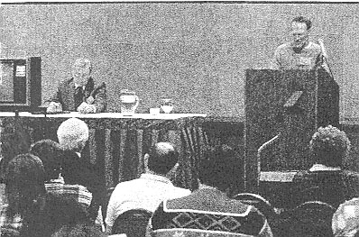
Phase II Action (The Visioning Conference)

Approximately 73 participants broadly represented the airport and community interests.

The conference structure was as follows:

- Welcome Remarks by the Prescott Mayor

- Keynote Presentation by the Editor of the “Airport Business” magazine (a national publication). He spoke on trends and challenges for the smaller airport.

A Panel Report on the Status Of The Airport
- The Airport Profile
- A Financial Snap-shot
- The Relationship To The Prescott Area
- Airport Master & Business Plans

- Second Keynote Presentation on Airport Development In Arizona.

- Breakout Into 7 Small Group “Visioning” Sessions (with Facilitators)

Topic: What Would You Like To See The Airport
Become In The Future?

- Facilitators Reports On The Visioning Conclusions

- Panel Of Facilitators Interaction With The Total Participants To Address:

Topic: Ways To Achieve The Output Of The Visioning Sessions.

- Conference Summary Statement (see following page)
LOVE FIELD BEYOND 2000
An Airport Visioning Conference

Phase III Action (The Report And Follow-on)

There were many paints and suggestions made at the Visioning Conference, but the most over-riding output was the improved attitude about the airport that began to emerge.

People started to talk to each other and discovered that their desires for the future of the airport were not so different. Questions were answered and misconceptions clarified.

An official announcement that a new Airport Manager would be recruited also stimulated many to look ahead with some enthusiasm to a new era for Prescott Airport. (This was not an encouraged resignation)

In the final report there was consensus on the following:
- The airport will continue to grow.

- There is a need for some form of regionalization which will require some type of Airport Authority and general partnering with the heavy users.

- A new terminal building is needed to serve all categories of users.

- Action should be taken to insure adequate zoning and land acquisition to provide a commercial buffer around the airport.

- Increase the business opportunities through the further development of the airport and a marketing effort.

- Upgrade the FBO type services to stimulate more interest among corporate aircraft to use Prescott Airport.

- Increase the capacity of the airport’s infrastructure and the air traffic control to handle the forecast traffic. Also improve the airport access.

- Improve the airport’s general appearance, pro-business atmosphere and general image as part of the process to attract new business interests.

- Develop some alternative source of funding to lessen the reliance upon fuel sales and hanger fees.

- Promote the airport to the public in the surrounding communities.

THREE YEARS LATER, THE AIRPORT IS THRIVING WITH THE ACTIVE
SUPPORT OF THE PRESCOTT COMMUNITY. THE NEW MANAGER HAS LISTENED TO THE SUGGESTIONS AND CONCERNS WHICH HAVE BEEN WOVEN INTO THE MANAGEMENT PROCESS WHENEVER FEASIBLE. EQUALLY SIGNIFICANT, THE PUBLIC HAS MADE FAMILY VISITS TO THE AIRPORT DURING AN ANNUAL AIRPORT OPENHOUSE WITH A FESTIVAL ATMOSPHERE.

THE VISIONING CONFERENCE WAS THE CATALYST WHICH BROUGHT ABOUT A SHIFT IN ATTITUDE. A NEW WILLINGNESS TO LOOK BEYOND THE FLAWS HAS OPENED THE DOOR TO PROGRESS AND PRIDE IN “THEIR” AIRPORT.

