TECHNICAL & SAFETY COMMITTEE

INTERNATIONAL PARACHUTING COMMISSION (FAI)

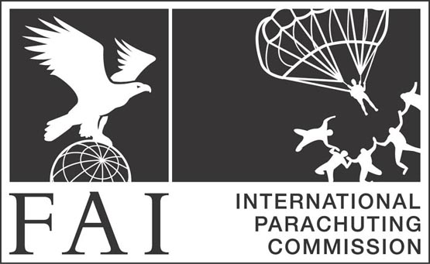

Technical & Safety Information Notice No. | Reserve Containers – All harness/containers, single and dual, manufactured by Parachutes de France.  W.N. 50
Date of Issue | 03 March 2015
Subject Matter and Applicability | Hydrolyze phenomena of the Cordura fabric used for the reserve container in extreme conditions of temperature and humidity.  All harness/containers, single and dual, manufactured by Parachutes de France.  The Bulletin, on page 2, was issued by Parachutes de France, when the company tested a container which had been returned for testing.  Riggers and packers of Parachutes de France containers are alerted to this issue and the Bulletin issued by Parachutes de France.
Note from Technical & Safety Committee | Users of all parachuting equipment should be aware that the integrity and proper performance of any equipment may be compromised by storage of the equipment in inappropriate or improper conditions, including extreme temperatures.
Compliance | Advisory, to be circulated to T&S Officers and widely distributed, as a matter of urgency.
Concerned Publication | E-mail to all T&S Officers; FAI/IPC website
Authority | Technical & Safety Committee, International Parachute Commission (FAI).

Technical and Safety Information Notices issued by the Technical & Safety Committee of the International Parachuting Commission (FAI) are issued as information and help to parachuting nations and their affiliated members. The Information Notices are of an objective informative nature and there is no direct or implied criticism of any manufacturer or product intended. The Information Notices do not claim to be complete.
The Information Notices may result from:-
- An incident or experience in the field being reported.
- A directive or notice issued by an aviation or government authority concerning parachuting operations or parachuting equipment.
- The issue of a notice by a manufacturer or by a National Parachuting Organisation.
In the case of equipment being the subject of the bulletin the reader is advised to check with the manufacturer regarding the current status or position of that equipment.

Technical & Safety Committee of IPC, IPC and FAI accept no liability for the use or misuse of any information contained in this Information Notice. The reader assumes all liability.

The Technical & Safety Committee, International Parachuting Commission, can be contacted
on e-mail - lmcnulty@skydiveireland.ie

Liam McNulty, Technical & Safety Committee, International Parachuting Commission.
03 March 2015

